vRealize Plug-in
V100R002C30
 | User Guide
 | Issue | 01
 | Date | 2017-09-29


Preface
Overview
This document describes the installation and operation and maintenance (O&M) of the Huawei vRealize plug-in.
Intended Audience
This document is intended for:
- Technical support engineers
- System maintenance engineers
Symbol Conventions
The symbols that may be found in this document are defined as follows.
Symbol | Description
 | Indicates an imminently hazardous situation which, if not avoided, will result in death or serious injury.
 | Indicates a potentially hazardous situation which, if not avoided, could result in death or serious injury.
 | Indicates a potentially hazardous situation which, if not avoided, may result in minor or moderate injury.
 | Indicates a potentially hazardous situation which, if not avoided, could result in equipment damage, data loss, performance deterioration, or unanticipated results.  NOTICE is used to address practices not related to personal injury.
Calls attention to important information, best practices, and tips.
NOTE is used to address information not related to personal injury, equipment damage, and environment deterioration.

Change History
Changes between document issues are cumulative. The latest document issue contains all the changes made in earlier issues.
Issue 01 (2017-09-07)
This issue is the first official release.
Contents
Preface ii
1 Overview 1
2 Installing and Uninstalling the Huawei vRealize Plug-in 2
2.1 Installing the Huawei vRealize Plug-in 2
2.2 Uninstalling the Huawei vRealize Plug-in 3
3 Configuring an eSight Instance 5
3.1 Adding an eSight Instance 5
3.2 Modifying an eSight Instance 7
3.3 Deleting an eSight Instance 9
4 Querying Server Information 10
4.1 Querying the Server List 10
4.2 Querying Component Information 11
4.3 Adding a Component View 12
4.4 Locating Alarm Information 17
5 Querying the Huawei vRealize Plug-in Version 20

Overview
The Huawei vRealize plug-in is a server management plug-in deployed in vRealize Operations Manager. It is compatible with vRealize Operations Manager 6.2 to vRealize Operations Manager 6.6. It is also compatible with eSight V300R007C00SPC503 or later. The vRealize Operations Manager UIs of different versions are different. In this document, vRealize Operations Manager 6.6 is used as an example.
The Huawei vRealize plug-in provides the following functions:
- Server information query: Queries the server list, basic component information, alarm information, and health status.
- Huawei vRealize plug-in version query: Queries the current Huawei vRealize plug-in version.
Table 1-1 lists the servers supported by the Huawei vRealize plug-in.
                - Supported servers
Type | Server
Rack server | RH1288 V3
Rack server | RH2288H V2
Rack server | RH2288 V3
Rack server | RH2288H V3
Rack server | RH5885 V3
Rack server | RH5885H V3
Rack server | RH8100 V3
Blade server | E9000
High-density server | X6000
High-density server | X6800

Installing and Uninstalling the Huawei vRealize Plug-in

Installing the Huawei vRealize Plug-in
            - Obtain the plug-in installation file, such as Huawei_vRealize_MP_1.0.5.pak.
            - On the vRealize Operations Manager WebUI, select Administration.
The Administration page is displayed.
            - In the navigation tree, choose Solutions.
The Solutions page is displayed.
            - Click.
The Add Solution dialog box is displayed.
            - Click BROWSE, and select the plug-in installation file, as shown in Figure 1-1.
            - Select Install the PAK file even if it is already installed., as shown in Figure 1-1.
            - Click UPLOAD, and upload the installation file, as shown in Figure 1-1.
              - Selecting a solution
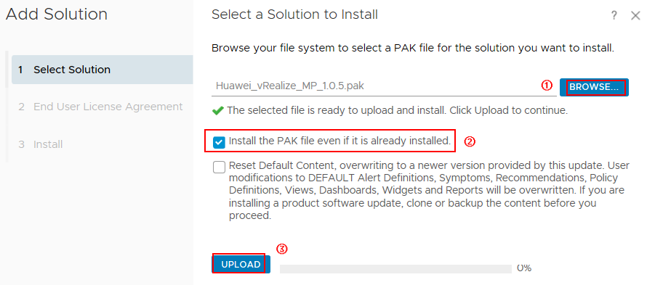

            - Click NEXT.
The Confirmation dialog box is displayed.
            - Click Yes.
The End User License Agreement page is displayed.
            - Select I accept the terms of this agreement, and click NEXT.
The Install page is displayed.
            - After the installation is complete, click FINISH.
On the Solutions page, view the installed Huawei vRealize plug-in.
----End

Uninstalling the Huawei vRealize Plug-in
            - On the vRealize Operations Manager WebUI, select Administration.
The Administration page is displayed.
            - In the navigation tree, choose Solutions.
The Solutions page is displayed.
            - Select the Huawei vRealize plug-in, and click, as shown in Figure 1-1.
              - Uninstalling the Huawei vRealize plug-in
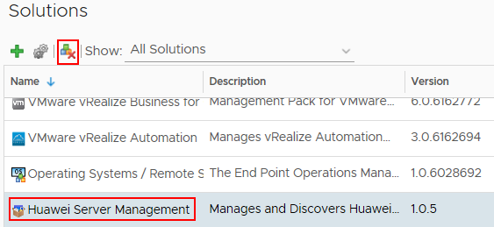

The Warning dialog box is displayed.
The uninstallation of the Huawei vRealize plug-in is supported only on vRealize Operations Manager 6.2 and vRealize Operations Manager 6.6. This function is not supported on vRealize Operations Manager of other versions currently.
            - Select I understand the risk and agree., and click OK.
The Huawei vRealize plug-in is uninstalled.
----End

Configuring an eSight Instance

Adding an eSight Instance
            - On the vRealize Operations Manager WebUI, select Administration.
The Administration page is displayed.
            - In the navigation tree, choose Solutions.
The Solutions page is displayed.
            - Select the Huawei vRealize plug-in, and click.
The Manage Solution - VMware vSphere dialog box is displayed.
            - In the Instance Settings area, set the following parameters, as shown in Figure 1-1.
              - Instance settings
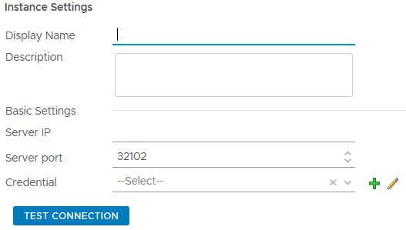

- Display Name: Set this parameter to a customized name. This parameter is used to identify the eSight instance.
- Description: Set this parameter to customized description, which provides supplementary information for the eSight instance.
- Server IP: Enter the eSight IP address.
- Server port: Enter the eSight port number.
            - In the Credential row, click.
The Manage Credential dialog box is displayed.
            - Set the following parameters, and click OK, as shown in Figure 1-1.
              - Manage Credential
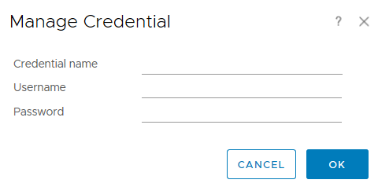

- Credential name: Set this parameter to a customized name. This parameter is used to identify the credential.
- Username: Enter the eSight user name.
- Password: Enter the eSight password.
            - Click TEST CONNECTION.
- If the connection is successful, the dialog box indicating a successful test is displayed.
- If the connection fails, check whether the eSight IP address, port number, user name, and password are correct.
- If no, change the parameter values, and click TEST CONNECTION again.
- If yes, contact Huawei technical support.
            - Click SAVE SETTINGS to save the eSight configuration information.
A dialog box is displayed, indicating that the configuration information is saved successfully.
            - Click OK.
The eSight instance is added.
            - Click CLOSE.
On the Solutions page, view the data collection status of the eSight instance.
----End

Modifying an eSight Instance
            - On the vRealize Operations Manager WebUI, select Administration.
The Administration page is displayed.
            - In the navigation tree, choose Solutions.
The Solutions page is displayed.
            - Select the Huawei vRealize plug-in, and click.
The Manage Solution - VMware vSphere dialog box is displayed.
            - In the navigation tree, select the name of the eSight instance to be modified, and determine whether to modify Basic Settings of the instance, as shown in Figure 1-1.
              - Modifying an eSight instance
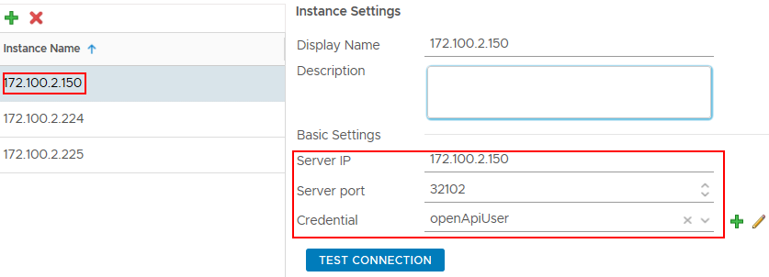

- If yes, perform Step 5 to Step 6.
- If no, go to Step 7.
            - Modify the following parameters, as shown in Figure 1-1.
- Display Name: Change the instance name.
- Description: Change the instance description.
- Server IP: Change the eSight IP address.
- Server port: Change the eSight port number.
- Credential: Click, and change the credential name, eSight user name, and password.
After an eSight instance is accessed, if the eSight port number, user name, or password is changed, you must synchronize the new port number, user name, or password to the vRealize Operations Manager system; otherwise, server management will be affected.
            - Click TEST CONNECTION.
- If the connection is successful, the dialog box indicating a successful test is displayed.
- If the connection fails, check whether the eSight IP address, port number, user name, and password are correct.
- If no, change the parameter values, and click TEST CONNECTION again.
- If yes, contact Huawei technical support.
Then go to Step 8.
            - Modify the following parameters, as shown in Figure 1-1.
              - Instance settings
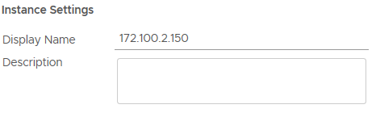

- Display Name: Change the instance name.
- Description: Change the instance description.
            - Click SAVE SETTINGS to save the eSight configuration information.
A dialog box is displayed, indicating that the configuration information is saved successfully.
            - Click OK.
The eSight instance is modified.
            - Click CLOSE.
On the Solutions page, view the data collection status of the modified eSight instance, as shown in Figure 1-1.
              - Collecting data
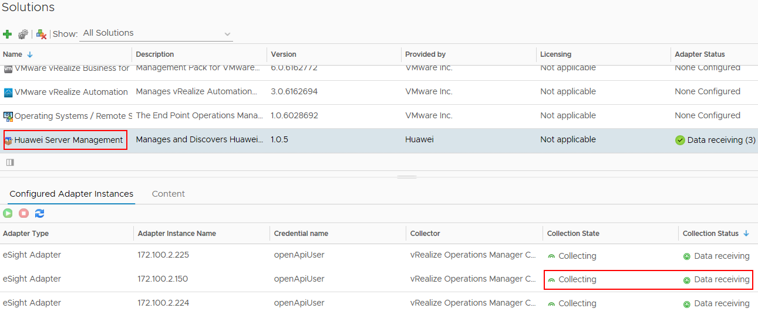

----End

Deleting an eSight Instance
            - On the vRealize Operations Manager WebUI, select Administration.
The Administration page is displayed.
            - In the navigation tree, choose Solutions.
The Solutions page is displayed.
            - Select the Huawei vRealize plug-in, and click.
The Manage Solution - VMware vSphere dialog box is displayed.
            - In the navigation tree, select the name of the eSight instance to be deleted, and click, as shown in Figure 1-1.
              - Deleting an eSight instance
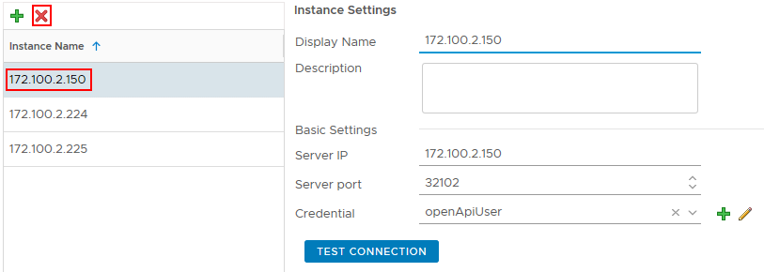

The Confirmation dialog box is displayed.
            - Select Remove related objects. (which is selected by default), and click YES.
The eSight instance is deleted.
----End

Querying Server Information

Querying the Server List
            - On the vRealize Operations Manager WebUI, select Environment.
The Environment page is displayed.
            - In the navigation tree, choose Huawei Server Management > Device Inventory tree.
The Device Inventory tree page is displayed.
            - In the navigation tree, query the server list, as shown in Figure 1-1.
              - Device Inventory tree
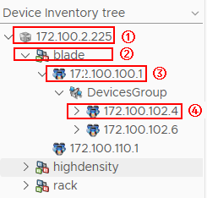

- (1) indicates the eSight IP address.
- (2) indicates the server type. blade indicates a blade server, highdensity indicates a high-density server, and rack indicates a rack server.
- (3) indicates the management module IP address.
- (4) indicates the blade server BMC IP address.
----End

Querying Component Information
            - On the vRealize Operations Manager WebUI, select Environment.
The Environment page is displayed.
            - In the navigation tree, choose Huawei Server Management > Device Inventory tree.
The Device Inventory tree page is displayed.
            - Choose eSight IP address > Server type > Server IP address > Component group > Component to be viewed, as shown in Figure 1-1.
              - Component information
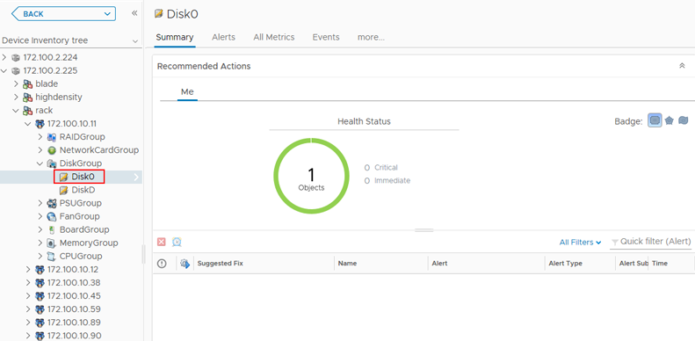

On the Summary tab, the component running status and alarm information are displayed.
            - Click All Metrics.
The All Metrics tab is displayed.
            - Choose All Metrics > Health Status, as shown in Figure 1-1.
              - Health status
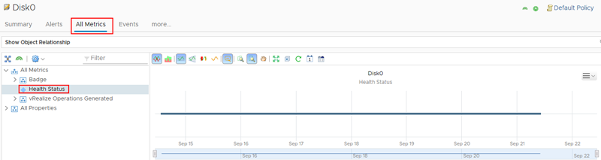

View the real-time status curve chart in the right pane.
----End

Adding a Component View
            - On the vRealize Operations Manager WebUI, select Environment.
The Environment page is displayed.
            - In the navigation tree, choose Huawei Server Management > Device Inventory tree.
The Device Inventory tree page is displayed.
            - Choose eSight IP address > Server type > Server IP address > Component group > Component, as shown in Figure 1-1.
              - Device Inventory tree
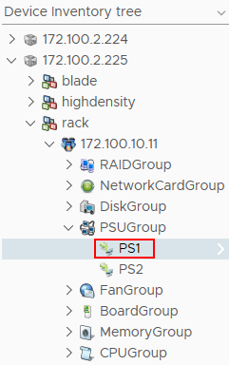

            - In the right pane, click Details.
The Details tab is displayed, as shown in Figure 1-1.
              - Details
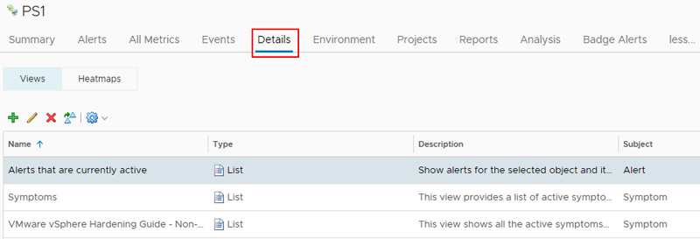

            - Click.
The New View dialog box is displayed.
            - In Name and Description, enter the name and description of the component view to be added.
            - In Presentation, select List, and preview the list in the right pane, as shown in Figure 1-1.
              - Presentation
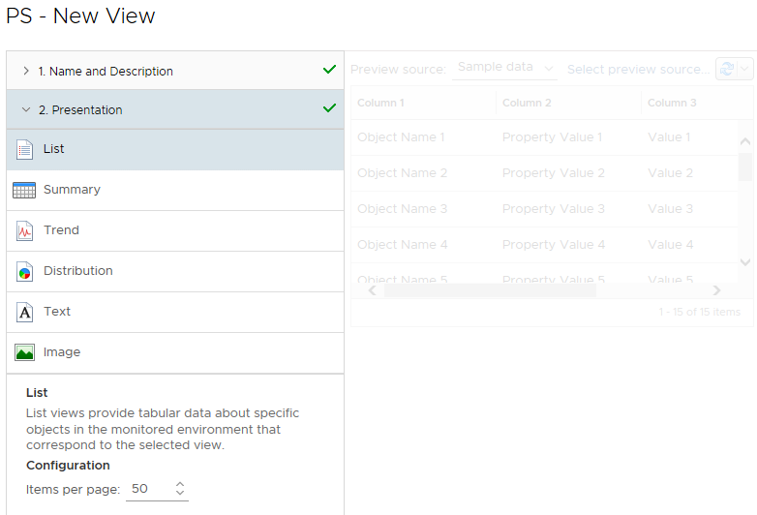

            - In Subjects, choose eSight Adapter > Component type to be added. For example, to add a component view to PS1, choose eSight Adapter > PSU.
            - In Data, select Metrics or Properties, double-click the attribute marked by, and view the newly added attribute in the Data area, as shown in Figure 1-1.
              - Data
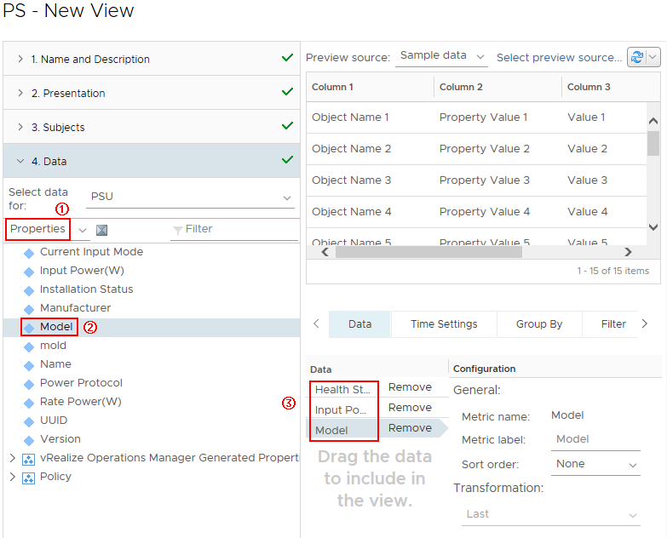

To delete an attribute, click Remove in the Data area. For example, to delete Health Status, click Remove in the Health Status row in (3).
            - In Visibility, retain the default settings, and click SAVE.
On the Details tab, view the newly added component view.
Select Server IP address in Device Inventory tree, choose Details > Newly added component view in the right pane, and view all views of this type of component of the server, as shown in Figure 1-1.
              - View
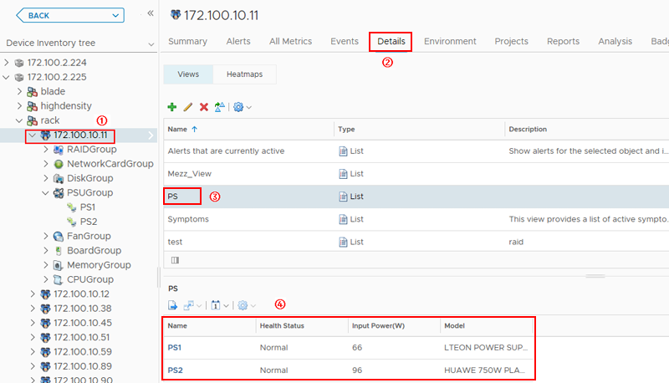

Select Server type in Device Inventory tree, choose Details > Newly added component view in the right pane, and view all views of this type of component of this type of server, as shown in Figure 1-2.
              - View
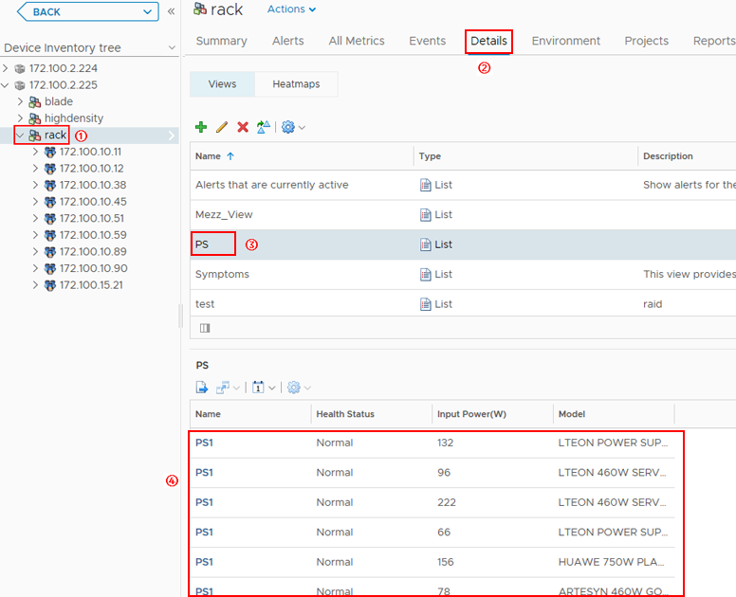

Select eSight IP address in Device Inventory tree, choose Details > Newly added component view in the right pane, and view all views of this type of component of the eSight system, as shown in Figure 1-3.
              - View
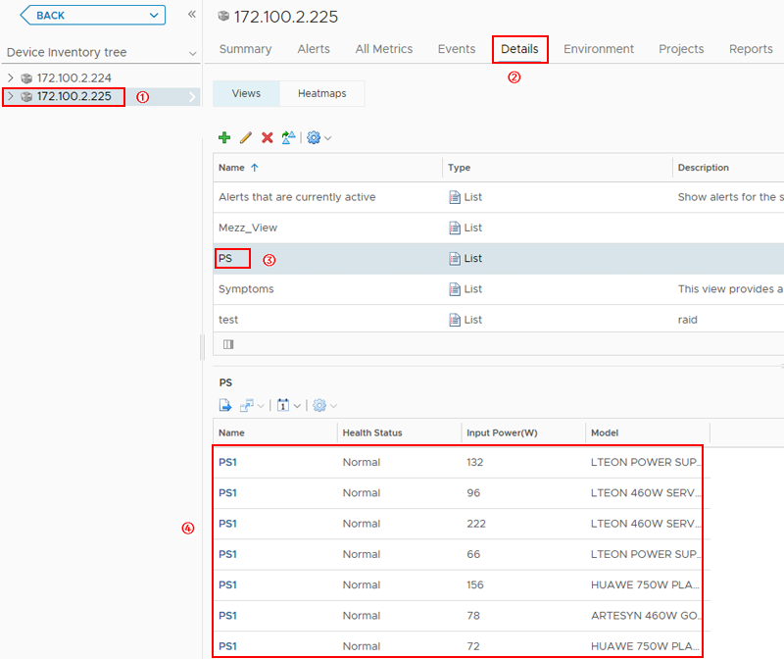

----End

Locating Alarm Information
            - On the vRealize Operations Manager WebUI, select Alerts.
The Alerts page is displayed.
            - In the navigation tree, choose All Alerts.
The All Alerts page is displayed.
            - In Group By, select Object Type.
            - In the alarm row of which the component is to be located, click Trigger object, as shown in Figure 1-1.


The trigger object can only be a component and cannot be a component group; otherwise, the server where the alarm is generated cannot be located.
              - All Alerts
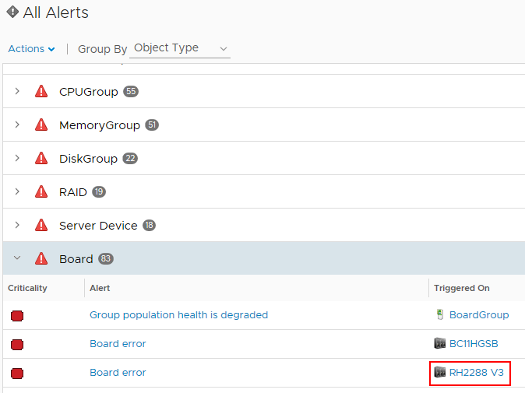

The trigger object information page is displayed, as shown in Figure 1-2.
              - Trigger object
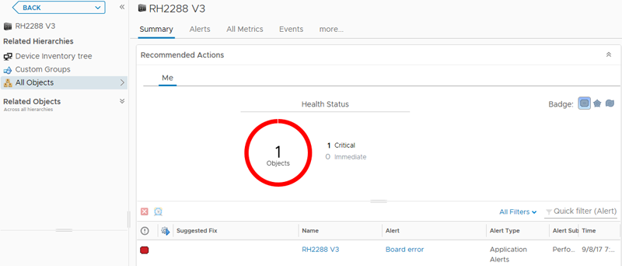

            - In the navigation tree, double-click Device Inventory tree.
The Device Inventory tree page is displayed, as shown in Figure 1-1.
              - Device Inventory tree
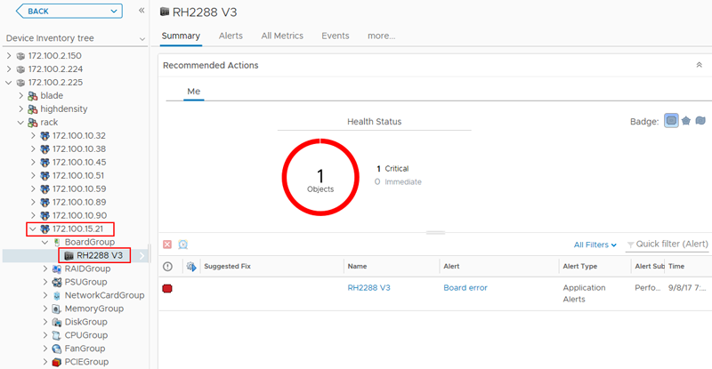

In the navigation tree, view the server to which the trigger object belongs.
----End

Querying the Huawei vRealize Plug-in Version
            - On the vRealize Operations Manager WebUI, select Administration.
The Administration page is displayed.
            - In the navigation tree, choose Solutions.
The Solutions page is displayed.
            - View the current Huawei vRealize plug-in version, as shown in Figure 1-1.
              - Solutions
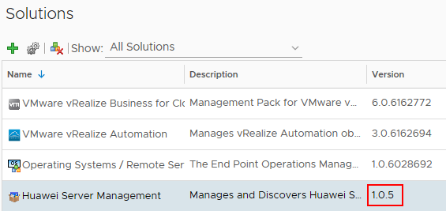
----End

